**Mini Project Report on**



**“Cartoonify Image With Machine Learning”**



**Submitted in partial fulfillment of the requirement for the award of the degree of**

**BACHELOR OF TECHNOLOGY**

**IN**

**COMPUTER SCIENCE & ENGINEERING**

**Submitted by:**

**Student Name: Mohammad Aves** **University Roll No.**

**2017515**

***Under the Mentorship of***

**Dr Vikas Tripathi Sir**



**Department of Computer Science and Engineering**

**Graphic Era (Deemed to be University)**

**Dehradun, Uttarakhand**

**January 2023**



**CANDIDATE’S DECLARATION**

I hereby certify that the work which is being presented in the project report entitled **“CARTOONIFY OF IMAGE USING MACHINE LEARING”** in partial fulfillment of the requirements for the award of the Degree of Bachelor of Technology in Computer Science and Engineeringof the Graphic Era (Deemed to be University), Dehradun shall be carried out by the under the mentorship of **DR. VIKAS TRIPATHI SIR**, Department of Computer Science and Engineering, Graphic Era (Deemed to be University), Dehradun.

Name : Mohammad Aves

University Roll no: 2017515**.**

**Table of Contents**

|  |  |  |
| --- | --- | --- |
| **Chapter No.** | **Description** | **Page No.** |
| Chapter 1 | Introduction | 4-5 |
| Chapter 2 | Literature Survey | 6-9 |
| Chapter 3 | Methodology | 9-11 |
| Chapter 4 | Result and Discussion | 12-13 |
| Chapter 5 | Conclusion and Future Work | 14 |
|  | References | 15 |

**Chapter 1**

**Introduction**

The craze of social media is extensively in these days. To become popular and followable person in this online crowd has always been a to-do on every person’s list on these social media platforms. Every user want to seek attention of followers and friends to create influence or to connect with them on such social platforms. I aim to provide one such creative solution to their needs, which is applying cartoon like effects to their images. Users can later share these images on any social media platforms, messengers, keep it for themselves, share it with loved ones or do whatever they like with it. Nowadays almost everyone is registered in social networks. They keep online status updated every day, share photos and comments, follow our friends’ news. To have a nice profile is a matter of prestige. You can use a photo of your own in a profile image, create an amusing avatar or turn your photo into a cartoon. With a pool of web applications available online, an image conversion to cartoon takes few clicks.

Creating a cartoon like effect is time and space consuming. Existing solutions to provide cartoon like effect to images are complex. Some solutions involve installing complex photo editing software like photoshop and other involve performing some task by user. Our research shows a website to carry out the task of Applying effects is more suitable, space efficient and takes minimum user efforts, for example toony photos is an existing website to perform such task but it is difficult to use as user has to markdown points & lines on the image to apply effects which is not user friendly also the options are limited. Hence there is a dire need for a website which is user friendly and performs the task of applying effects to images very well.

Following is our brief research on existing solutions:

**1. Image Enhancement:-** The majority of photo editing websites offer the so- called Image Enhancement. The main advantages of online photo to image enhancement apps are simplicity and quickness. You’ll have to upload a photo from your computer or from the web, find image enhancement in the tool set and press the button Apply. The image processing varies from several seconds up to 1-2 minutes.

**2. Cartoonify:-** Many people prefer to use online photo editors. They are compatible to more platform and allow you to edit photos at anytime and anywhere. There are lots of online cartoon photo editor on the internet, you can choose one of them to make your photo into cartoon.

**3. Water Colour:-** This is also a good option for photo editing. A watercolor portrait avatar makes you stand out. It shows your unique attitudes and personality. Try to get a watercolor portrait by water coloring your pictures with Fotor's free watercolor filter.

**4. Pastel Colour:-** Pastels are a different type of medium as they are the medium halfway between paints and pencils. They are essentially a very thick stick made mostly out of pigment and some binder that will allow the pigment to keep its shape and make it possible to handle it like a pencil and draw with it.

**5. Pencil Sketch:-** Pencil is a very versatile artistic medium. From quick caricatures in a sketchbook to polished landscape drawings, pencil has the potential to bring all kinds of creative ideas to life.

**5. Pencil Colour Sketch:-** It is same as pencil sketch but it has colour. Pencil sketch is black and white but this is colourful.

**Chapter 2**

**Literature Survey**

To improve the performance of GAN and enhance output in the task they trained diferent models that would generate a single object and train another model which would learn to combine various objects according to text descriptions. Xinrui wang and zinze yu proposed three cartoon representations based on their observation of cartoon painting behaviour: the surface representation, the structure representation, and the texture representation. Image processing modules are then introduced to extract each representation. A GAN-based image cartoonization framework is optimised with the guide of extracted representations. Users can adjust the style of model output by balancing the weight of each representation. Extensive experiments have been conducted to show that their method can generate high-quality cartoonized images. Their method outperforms existing methods in qualitative comparison, quantitative comparison, and user preference. Anusha Pureti,Ch.Sravani Y. Pavankumar ,T. Venkateswarlu ,G. Jahnavi A.Hema proposed a profcient technique for objects extraction from animation pictures and it depends on broad suppositions identified with shading and areas of items in animation pictures, the items are commonly gravitated toward the focal point of the picture, the foundation tones is the all the more much of the time gravitated toward the edges of animation picture, and the item colours is less touch for thedges. The cycles of shading quantization, seed filling and found the item apparition have been utilized. The after effects of led tests showed that the framework have promising effectiveness for extricating both single or multi objects lay in straight forward and complex foundations of animation pictures. Debasish Pal and Ashim Jyoti Gogoi took Consideration of textured images and propose to model their textural content by a set of features having a perceptual meaning and their application to content-based image retrieval and proposed a novel Internet image search approach. The earliest work on Content Based Image Retrieval was done by Ning-San Chang and King-Sun Fu in their paper Query-by-Pictorial-Example. They introduced Query-by-Pictorial-Example as a relational query language for manipulating queries regarding pictorial relations as well as conventional relations. Content-based image /video retrieval system for the World Wide Web was implemented by John R. Smith and Shih-Fu Chang . They provided a suite of tools called Visual SEEk with which a person may search for and retrieve images and videos over the Web. Stefan van der Walt , Johannes, L. Schonberger, ̈ Juan Nunez-Iglesias, François Boulogne, Joshua D. Warner , Neil Yager proposed a system that provided high quality, well-documented and easy-to-use implementations of common image processing algorithms. To divide the foreground and background, they threshold the image to produce a binary image. They created an well documented application programming interface (API) along with tools that facilitate visualisation contribute to the learning experience, and make it easy to investigate the effect of different algorithms and parameters. The Cartoonify uses the system Python three.9, then it additionally uses OpenCV that provides a true time optimized pc Vision library, tools, and hardware. Pre-processing is a vital a part of our model. It helps to smoothen the image, filter the options, changing it to sketches, and translating the output from a website to a different. once implementing this connected work, we {will|we are able to} take care that the output generated by our model will offer U.S. the simplest output that retains the best quality options. we tend to divide the image into regions and outline a predicate for activity the boundary between 2 regions. supported the predicate segmentation, associate degree rule is developed whose call relies on a greedy technique however still helps to satisfy international properties. once identification of contours, we tend to implement Gradient Ascent to initialize the image with rough clusters and iteratively amend the clusters till convergence. Advancing the method, to develop a cartoon-like segmentation technique we'll seize international content info and manufacture much usable results for celluloid vogue cartoon workflows. To extract swish and cartoon resembling surfaces from pictures, guided filters area unit used. A guided filter is a sophisticated version of Bilateral filters with higher close to the sting behaviour. The goal is solely removing/significantly decreasing the noise and getting helpful image structures. The filtering output of the guided filter is associate degree best linear remodel of associate degree input image. Following the approach of Bilateral filters, it retains smoothing property and additionally, is free from gradient reversal artifacts. A generative adversarial network (GAN) may be a category of machine learning frameworks is employed in our computer code. the GAN model. every frame is iteratively processed and trained with random noises in Generator. when obtaining losses the soul and Generator gets trained utterly as cartoons. Finally, a cartoon image is obtained. The video is split into pictures victimisation frame separation. In video and animation, frames area unit individual footage in an exceedingly sequence of pictures. to get new pictures, it uses Generator and soul. The generator makes pictures and therefore the soul checks pictures to be real or pretend and so sends feedback to the generator therefore asking him to get higher information. The a lot of each networks area unit trained, the higher pictures we have a tendency to get. MEDIAN FILTER – This filter helps in reducing the noise created throughout the downscaling of the image and later changing the initial image to cartoon image by applying the bilateral filter. Any extreme specks area unit ironed over. EDGE DETECTION – initially the noise of the image is removed inside the image. Later the smoothed image is filtered victimisation horizontal and vertical direction by dividing the cells of the image part.

**Chapter 3**

**Methodology**

**SOFTWARE REQUIREMENTS:**

**Python 3** - We have used Python which is a statistical mathematical programming language like R instead of MATLAB due to the following reasons:

1. Python code is more compact and readable than MATLAB

2. The python data structure is superior to MATLAB

3. It is an open source and also provides more graphic packages and data sets

**Keras** (with **TensorFlow** backend 2.3.0 version) - Keras is a neural network API consisting of TensorFlow, CNTk, Theano etc.

Python packages like **Numpy**, **Matplotlib** for mathematical computation and plotting graphs.

**VS Code** 1.63.2 was used for creating the whole project.

**Pip install flask** – a web application framework was used. Flask is a web application framework written in Python. Armin Ronacher, who leads an international group of Python enthusiasts named Pocco, develops it. Flask is based on Werkzeug WSGI toolkit and Jinja2 template engine. Both are Pocco projects.

**HARDWARE REQUIREMENTS:**

Processor: Intel® Core™ i3-2350M CPU @ 2.30GHz

Installed memory (RAM):4.00GB

System Type: 64-bit Operating System

**PROJECT STRUCTURE:**

My Project contains different files which is shown below:

1. **app.py** - This contains Flask APIs that receives input through API calls and gives the desired output as per request.

2. **HTML/CSS** – This contains the HTML template and CSS styling to allow users to enter the values.

**APPLICATION:**

In this project, I have created a **Flask API** called **app.py** to get the input from the users and gives the desired output as per request.

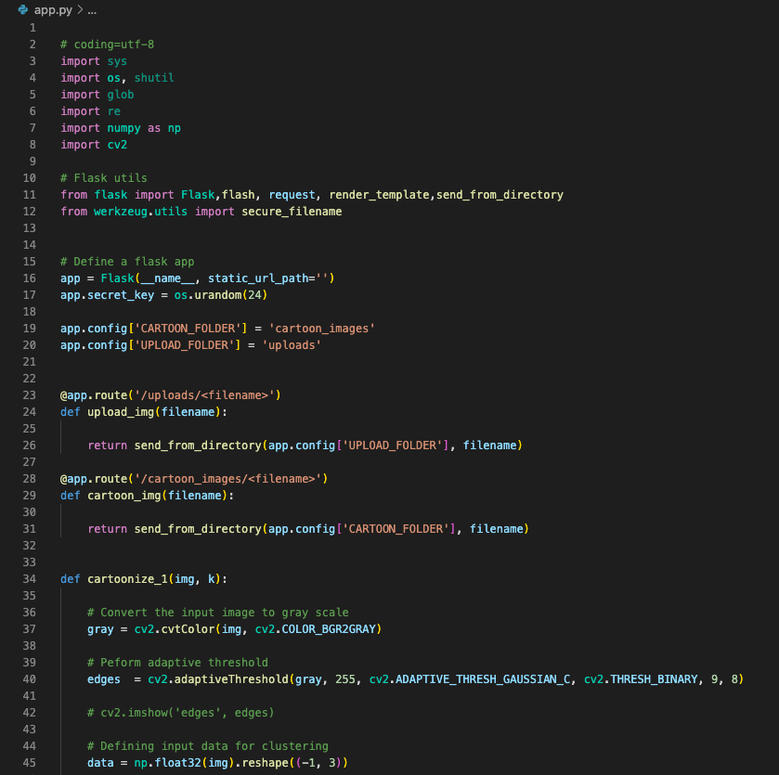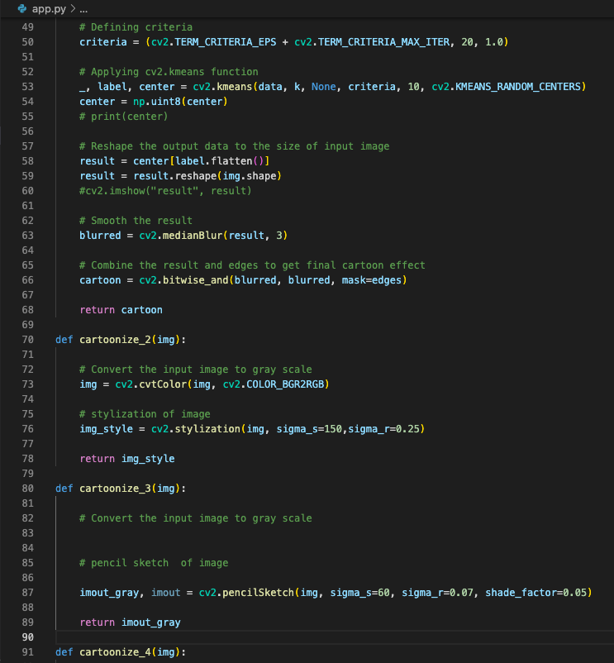

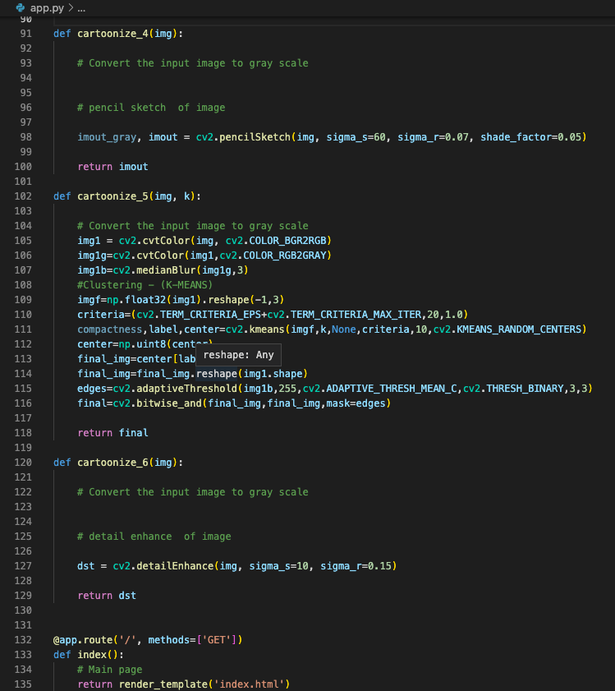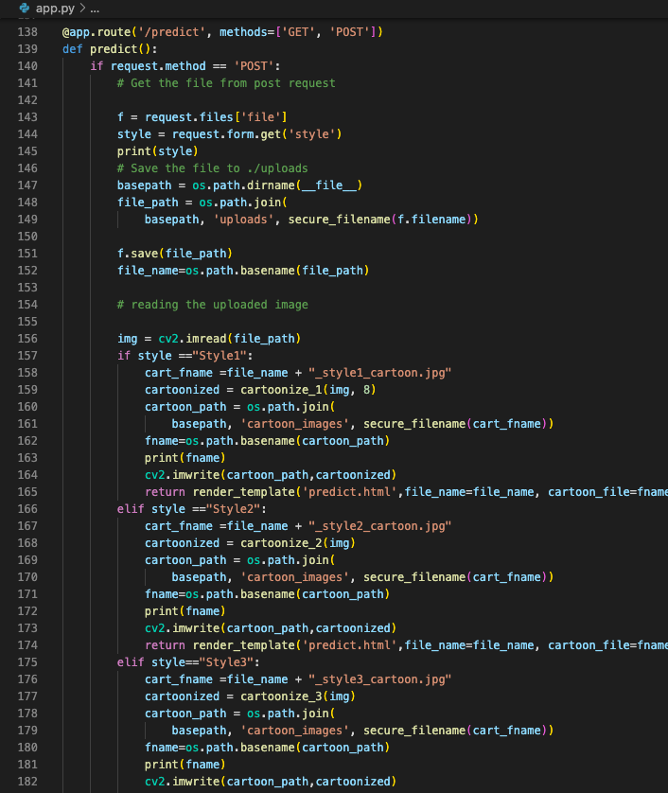

**Chapter 4**

**Result and Discussion**

1. **Image Enhancement:-**

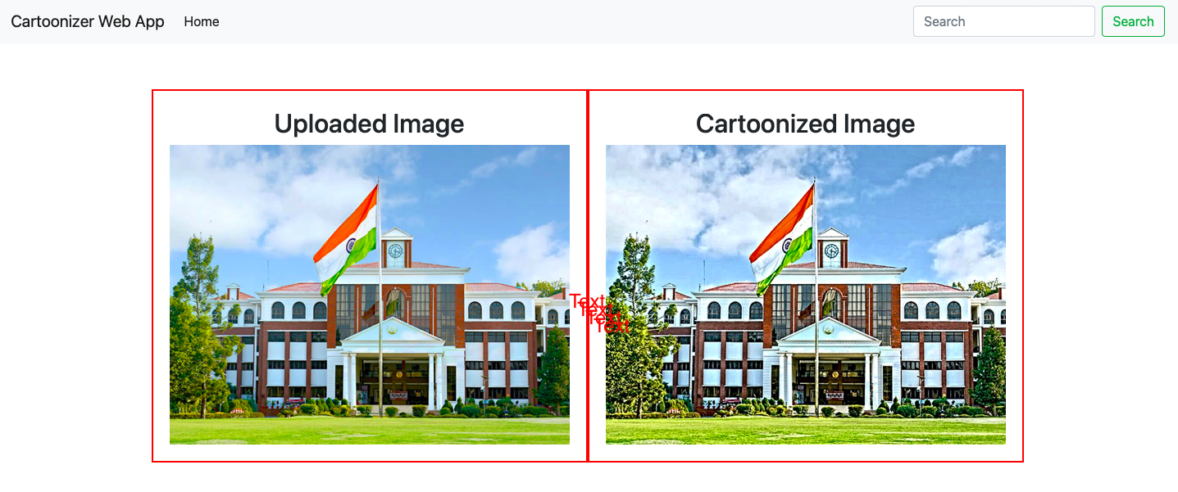

**2. Cartoon:-**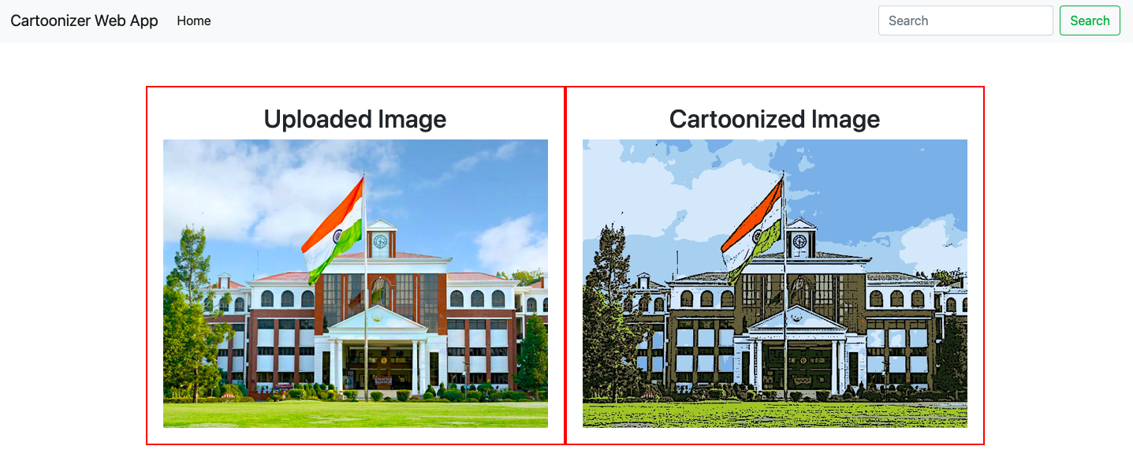

**3. Water Colour:-**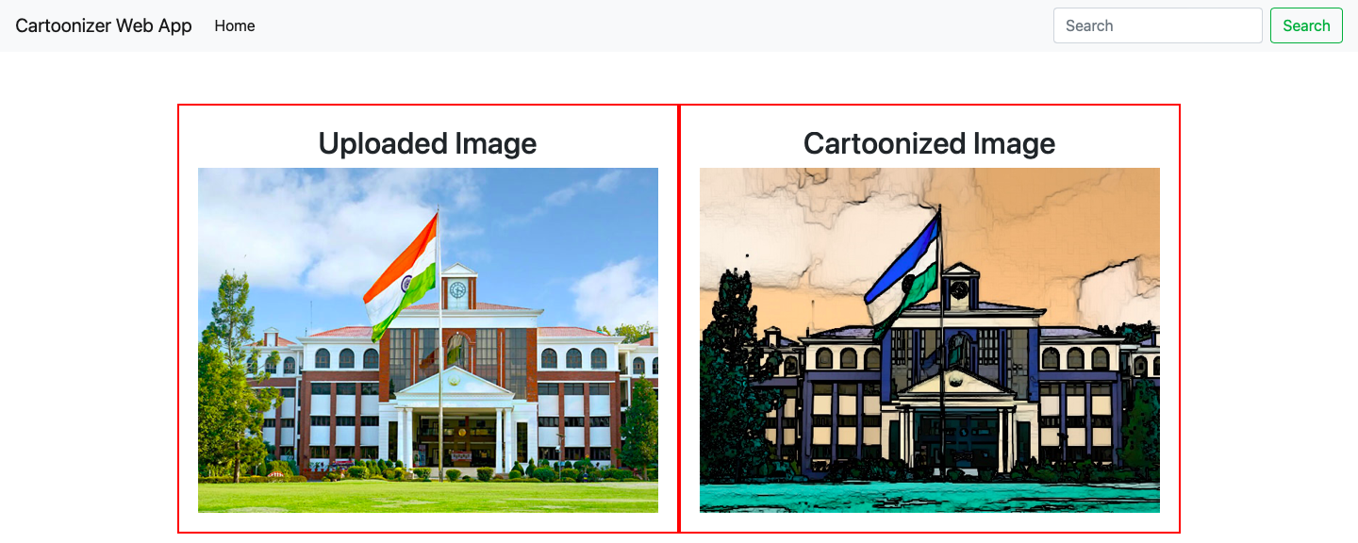

**4. Pastel Colour:-**

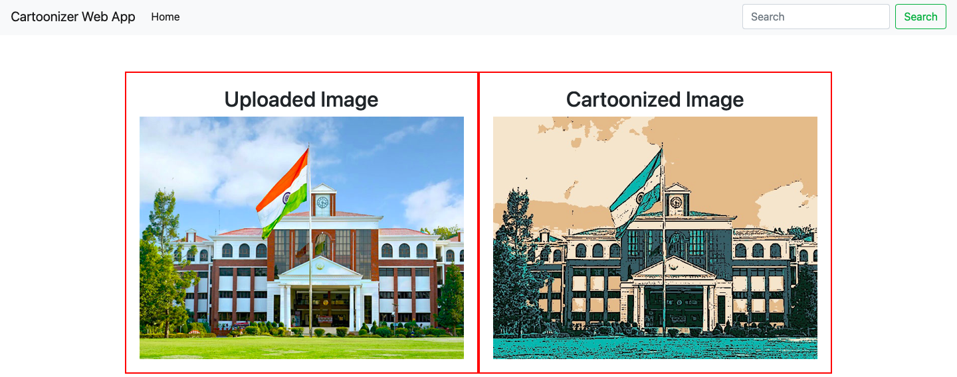

**5. Pencil Sketch:-**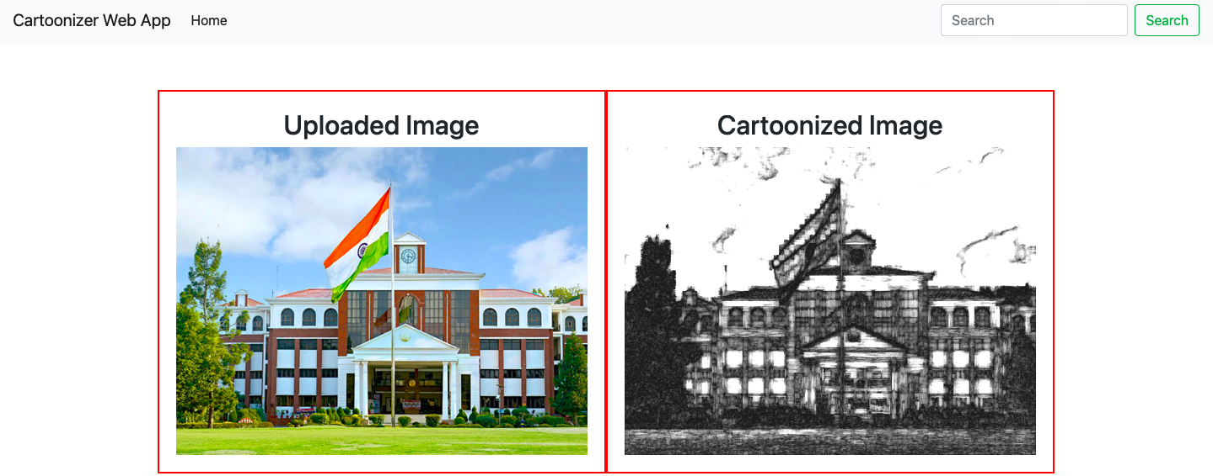

**6. Pencil Colour Sketch:-**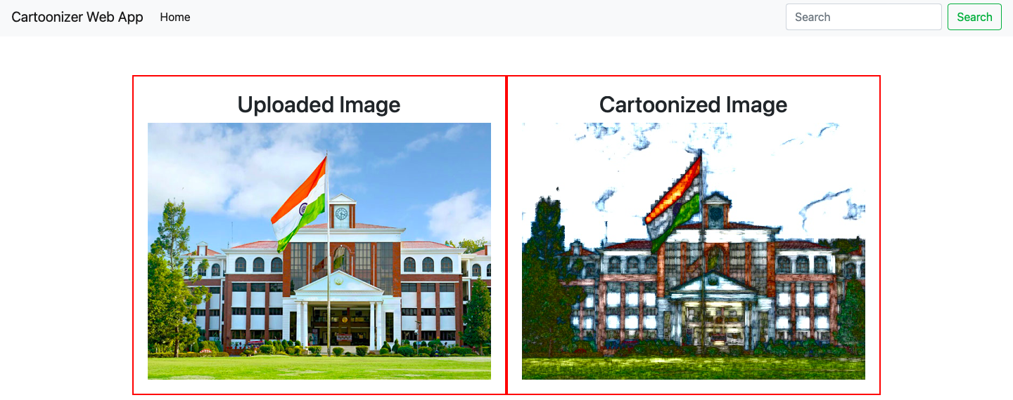

**Chapter 5**

**Conclusion and Future Work**

**Conclusion :-** First of all, the basic tools to handle the titled problems of the thesis are incorporated. It includes the origin and history of image processing, different types of uncertain environments, existing methods for cartoon imaging. Amid the previous three decades, the topic of image processing has gained vital name and recognition among researchers because of their frequent look in varied and widespread applications within the field of various branches of science and engineering. As an example, image processing is helpful to issues in signature recognition, digital video processing, Remote Sensing and finance. Conclusion and Future Directions Firstly, we use a high-resolution camera to take pictures of the internal structure of the wire. Secondly, we use OpenCV image processing functions to implement image pre-processing. Thirdly we use morphological opening and closing operations to segment images because of their blur image edges. The main attraction of the paper is to solve different types of images having one object, two objects and three objects which can’t be solved by any of the existing methods but can be solved by our proposed method. The cartooning of images has a tremendous scope in the animation industry. Animated pictures are used in advertisement to keep the audience engaged. Cartooning of images also have a huge scope to print publications, and publishing companies. Gaming sector is looking very promising.

**Future Work :-** Currently the system is facing issues with face cartoonization. This can be improved by providing more facials data with different perspective to the model. The resolution of the output also need to be increased.

**References**

[1]Y. Chen, Y.-K. Lai, Y-J. Liu. "cartoonization using white box representation", International Conference on Image Processing, 2020

[2] Y. Chen, Y.-K. Lai, Y-J. Liu, "Literature sure on CBIR Technology". International Conference on Image Processing. 2020

[3] Zengchang Qin, Zhenbo Luo. Hua Wang. "scikit-image processing in python", International Conference on Image Processing, 2014

[4] Wikipedia

[5] K. Beaulieu and D. Dalisay, "Machine Learning Mastery", Machine Learning Mastery, 2014